Lab-1

**Aim: Recording types of data and various file formats. Identifying data sources.**

**Handling traditionally to start with at small scale.**

Rahil Acharya

CE004

20CEUOD004

Data Types

1. Student Information : Structured
2. Book Information : Structured
3. Feedback Form : Structured
4. Issuing and returning book information : Structured
5. E-Learning content : unstructured
6. Web Pages : Semi Structured

**Database** vs. **Data Warehouse**

**- Database**

* Used in OLTP
* Optimised for write operation
* Current Data
* Application Oriented
* Normalised Data

**- Data Warehouse**

* Used in OLAP
* Optimised for read operation
* Historical Data
* Subject Oriented
* Denormalized Data
* **Given the spreadsheet file convert it into a csv**

<https://www.zamzar.com/convert/xls-to-csv/>

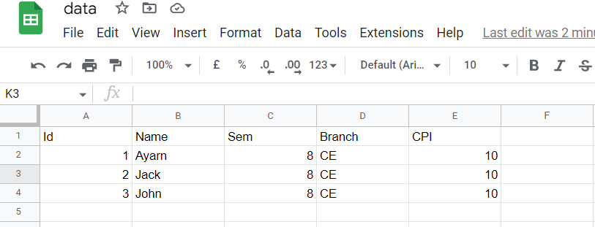

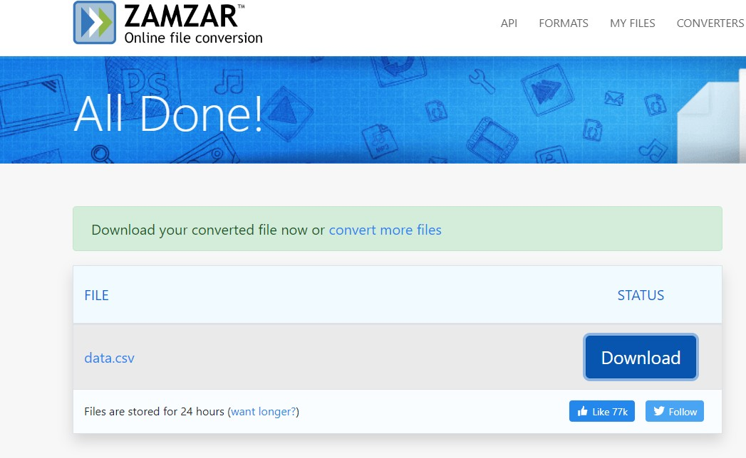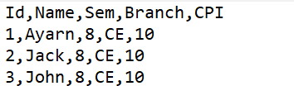

* Import a csv into MySQL database table

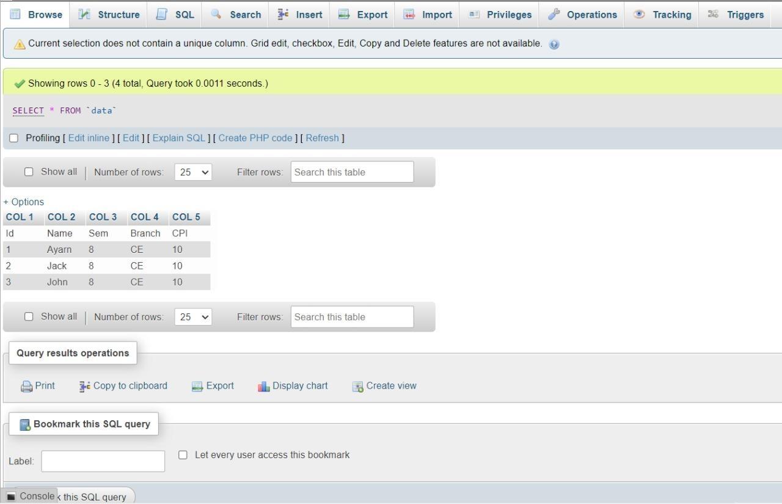

* Write a computer program to read records from database and generate data file.
* XML
* JSON

**Convert CSV to Database file into sqlite.**

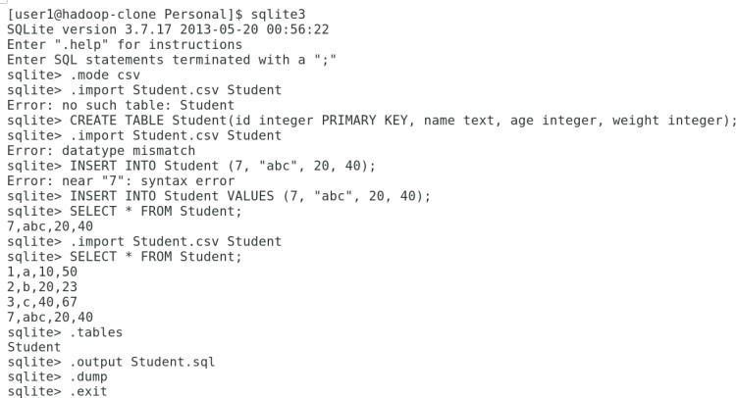

**CSV To XML Using ‘convertcsv.com’**

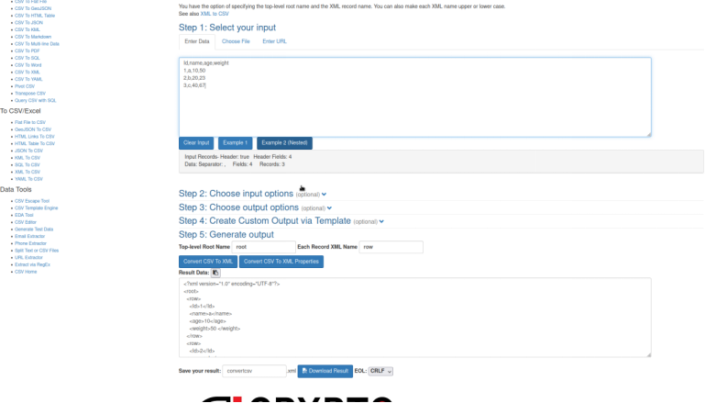

**CSV To JSON Using ‘csvjson.com’**

